

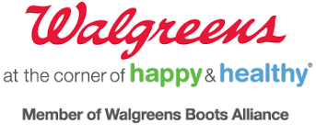

**REWARDS FOR MAMMOGRAMS PROGRAM**

**GET a mammogram. GET rewarded.** **HELP SAVE** a **Life**.

**FREQUENTLY ASKED QUESTIONS FOR FACILITIES:**

**Are there any reporting requirements?**

-Yes. Komen will require a monthly count of the number of vouchers signed and distributed for tracking purposes. The final number of participants/vouchers redeemed will be announced in October 2017.

**Can we distribute the pamphlets before a patient receives the actual mammogram?**

-No. Treat the voucher as a coupon with a monetary value attached. Special consideration will be given if you can guarantee 100% that a patient will/has/is receiving a mammogram at the time of distribution

**Can the patient transfer the points (i.e. can the person who received the mammogram give the signed voucher to someone else to redeem)?**

-No. The reward points are intended to be redeemed by the person receiving the mammogram

**FREQUENTLY ASKED QUESTIONS FOR PATIENTS:**

**What is the deadline to redeem the reward points (not the mammography appointment)?**

-12/31/17

**Can the points be used for the pharmacy?**

-No. Redemption for the balance rewards points excludes charitable donations, pseudoephedrine or ephedrine products, clinic services, prescriptions, pharmacy items or services, sales tax, shipping and the Prescription Savings Club membership fee. You can also find a full list of exclusions at walgreens.com/balance

**Where do I go to redeem the reward points?**

-Points can be redeemed at any Chicagoland Area Stores

**What if I do not see my mammography facility on the list of partner sites?**

-If your preferred location is not listed, then call the Komen Chicago Office at (773) 444-0061 or go to [www.komenchicago.org/walgreens](http://www.komenchicago.org/walgreens) and click patient information